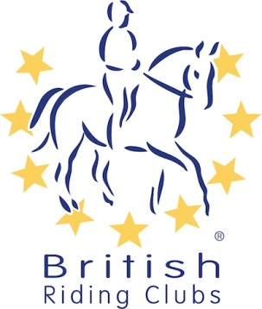
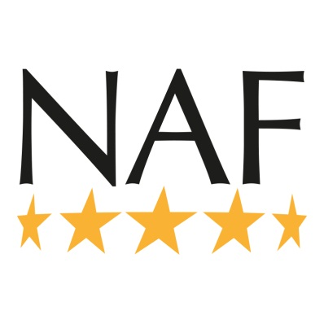
.
British Riding Clubs
Area 14 Dressage and Riding Test Qualifiers
for BRC 2019 National Championships

Sunday 9 June 2019
Geldeston Hall NR34 0LP
Classes | Tests | Entry Fee | Entry Notes
1 NAF Magic Junior Dressage  A Team Qualifier  B Area-Only Team | Prelim 2 (2016)  Prelim 12 (2005)  Prelim 13 (2006)  Novice 30 (2006) | £45 per team | Class 1A entries are automatically entered into Class 2 as Individuals
2 NAF Magic Junior Dressage  Individual Qualifier | Prelim 2  Prelim 12  Prelim 13  Novice 30 | £10 per test | Remember to state which test is being ridden on entry form.
3 NAF Magic Junior Elementary Dressage  Individual Qualifier | Elem 40 (2010) | £10
4 NAF Magic Junior Riding Test  A Team Qualifier  B Area-Only Team | Prelim 7 (2002) | £45 per team | Class 4A entries are automatically entered into Class 5 as individuals
5 NAF Magic Junior Riding Test  Individual Qualifier | Prelim 7 (2002) | £10
6 NAF Magic Junior Intro Dressage  Individual Qualifier | Intro B (2009) | £10
7 NAF Magic Senior Intro Dressage  Individual Qualifier | Intro B (2009) | £10
8 NAF Magic Senior Prelim Dressage  A Team Qualifier  B Area-Only Team | Prelim 12 (2002)  Prelim 13 (2006)  Prelim 14 (2006)  Prelim 15 (2008) | £45 per team | Class 8A entries are automatically entered into Class 9 as Individuals
9 NAF Magic Senior Prelim Dressage  Individual Qualifier | Prelim 12 (2002)  Prelim 13 (2006)  Prelim 14 (2006)  Prelim 15 (2008) | £10 per test
10 NAF Magic Senior Open Dressage  A Team Qualifier  B Area-Only Team | Novice 24 (2010)  Novice 34 (2009)  Novice 38 (2005)  Elem 43 (2006) | £45 per team | Class 10A entries are automatically entered into Class 11 as Individuals
11 NAF Magic Senior Open Dressage  Individual Qualifier | Novice 24 (2010|) | £10 per test
 | Novice 34 (2009)
 | Novice 38 (2005)
 | Elem 43 (2006)
12 NAF Magic Open Pick a Test  Medium/Adv Medium  Individual Qualifier | Medium 61 (2002) | £10 per test | Seniors and Juniors may compete in one or both tests, in the latter case 2 entry fees should be paid.
 | Adv Medium 91 (2016)

13 NAF Magic Senior Riding Test  A Team Qualifier  B Area-Only Team | Prelim 2 (2016) | £45 per team | 2 riders ride each test, pls indicate on entry form.  Class 13A entries are automatically entered into class 14 as Individuals
 | Novice 30 (2006)
14 NAF Magic Senior Riding Test  Individual Qualifier | Prelim 2 (2016) | £10 per test | Remember to state which test is being ridden on entry form.
 | Novice 30 (2006)
15 NAF Magic Senior Pairs Dressage | BRC Pairs 5 (2014) | £20 per pair
16 NAF Magic Junior Pairs Dressage | BRC Pairs 5 (2014) | £20 per pair

This competition is run under British Riding Club 2019 Rules and is being organised by a sub-committee of Area 14 Liaison Committee. It is important that Teams Managers and competitors are aware of current Rules and eligibility relating to this competition, there are new classes and some eligibility changes for 2019 - check the current BRC Handbook appendix 2 & 3 (p. 94) or online at www.britishrdingclubs.co.uk

Entrants to qualifiers must pay a prelim entry to BRC head office of £30 per team, £15 for pairs or £9.50 per individual at least 21 days before the date of this qualifier. Entry forms can be found on the BRC website (see above) for postal entries, or online entries can be made via the BHS bookshop www.britishhorse.com. Late prelim entries may be accepted at the discretion of the Organiser with a late surcharge of £20 per team and £10 per individual, so long as there are sufficient spaces. Late entries cannot be guaranteed, therefore cannot be paid for until the Organiser has approved the late entry.

If the date of the qualifier is cancelled for any reason, the closing date of prelim entry will remain. However, if the qualifier is moved more than 21 days later, entries will be re-opened but late entry fees cannot be refunded. Eligibility will be approved at the original close of prelim entry.

All hats must have a visible aqua BRC hat tag in place before they are used in warming up and competing in order to meet current BRC safety standards. There will be a trained official available on the day to check your hat if it is not tagged. For up to date hat specifications see the current BRC Handbook.

Your horse must have up to date influenza vaccinations in line with Rule G7 in the current BRC Handbook (pp. 19-20). There is also a checking device on the BRC website, but if you are unsure, please call BRC on 02476 840518. Due to concerns over a flu epidemic BRC are recommending that horses should have had a booster within 6 months of a qualifier competition.

NB IT IS A CONDITION OF ENTRY that all clubs entering team classes must provide the name and contact number of at least one helper for at least half the day. Please could team managers indicate if any RIDERS are volunteering so that clashes with dressage times can be avoided.

**** PLEASE NOTE ****
NO DOGS ALLOWED AT THIS VENUE
TEAM MANAGERS PLEASE ENSURE THAT YOUR MEMBERS AND THEIR SUPPORTERS ARE AWARE

General Enquiries and Volunteers:
Mrs Marcia Fenwick Tel: 01502 711010 / 07979 500884 or mf.geldeston@btinternet.com

___________________________________________________________

Entries to:
Mrs Jill Hillyard, 1 Dovedale, Felixstowe, Suffolk IP11 2PL
Tel: 01394 286986 / 07855 902759 (before 9 pm please) or jillyhilly@aol.com

Entries, including Area-Only team entries (B sections), MUST be submitted on BRC AREA ENTRY FORMS, which can be downloaded at http://www.bhs.org.uk/enjoy-riding/british-riding-clubs/brc-downloads. Entries may be accepted by email subject to cheque being received by Saturday 25 May 2019.

Please make cheques out to: British Horse Society Area 14

ENTRIES CLOSE Wednesday 29 May 2019

Dressage times will be sent to Team Managers by 5 June and posted on BRC Area 14 Facebook

Equestrian photography by Steve Wood of Beccles

Event catering by Jenni Osborne 07876 265165

